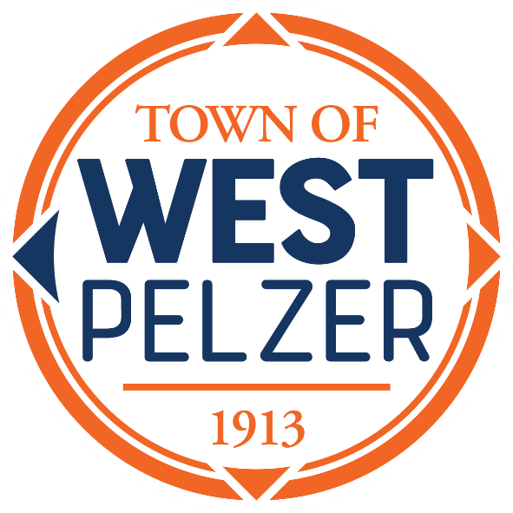

BUDGET WORKSHOP
Friday March 3, 2023
1:00pm
O’Dell Community Center
3 Hindman Street

- CALL TO ORDER

- BUDGET OVERVIEW
FY 2022-2023

- DISCUSSION OF ARPA BUDGET

- DISCUSSION OF 2023-2024 FISCAL YEAR BUDGET

- EXECUTIVE SESSION
For the purpose of discussion of contractual matters related to the 2023-2024 fiscal year budget

- ADJOURNMENT

