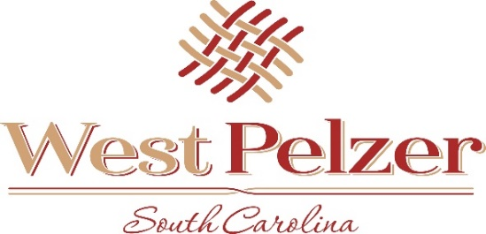
COUNCIL AGENDA
Tuesday September 7, 2021
6:00pm
West Pelzer Municipal Center
30 Main Street

- INVOCATION/PLEDGE OF ALLEGIANCE

- CALL TO ORDER

- APPROVAL OF MEETING MINUTES
  - August 3, 2021 Council Meeting

- PRESENTATIONS AND REPORTS
  - Paula Payton - Clerk’s Report
  - Chief Stoller – Police Department Report
  - Judge Cole– Swearing-In of Chief Scott Stoller
  - Mayor Sanders – Grand Gallery – Taylor Harrison

- CITIZEN COMMENTS (sign up required / max 3 minutes

- OLD BUSINESS

- NEW BUSINESS
  - PUBLIC HEARING
    - For Traffic Calming Devices on secondary roads for the Town of West Pelzer
  - Resolution 2021-0907 “RESOLUTION TO INSTALL ADDITIONAL FOUR-WAY STOPS
ON SECONDARY ROADWAYS WITHIN THE TOWN OF WEST PELZER”
  - Ordinance 2021-0907 “AN ORDINANCE TO REZONE APPROXIMATELY 0.80 ACRES
OF REAL PROPERTY LOCATED NEAREST 17 PARK STREET, WEST PELZER, SOUTH
CAROLINA. TAX MAP NUMBER 2430413001”
  - Ordinance 2021-0907.1 “AN ORDINANCE TO ADOPT A REVISED BUSINESS LICENSE
ORDINANCE IN ACCORDANCE WITH THE BUSINESS LICENSE STANDARDIZATOIN ACT
(2020 ACT NO. 176)”
  - Resolution 2021-0907.1 “A RESOLUTION TO POSTPONE RESIDENTIAL LANDLORD
- BUSINESS LICENSE FEES”
  - Resolution 2021-0907.2 “A RESOLUTION GRANTING A SPECIAL EXCEPTION
PURSUANT TO THE TOWN OF WEST PELZER ZONING ORDINANCE TO PROVIDE FOR IN-
HOME CHILD CARE SERVICE AT 8 PARK STREET, WEST PELZER, SOUTH CAROLINA”
  - Resolution 2021-0907.3 “A RESOLUTION REQUESTING CAPITAL FUNDING TO
UPDATE THE 2017 COMPREHENSIVE PLAN AND 2017 MASTER PLAN FOR THE
TOWN OF WEST PELZER, SOUTH CAROLINA”
  - Resolution 2021-0907.4 “DESIGNATING AN AUTHORIZED REPRESENTATIVE
AND CONTACT PERSON FOR PURPOSES OF THE AMERICAN RESCUE PLAN
ACT OF 2021”

- REQUEST BY COUNCIL

- EXECUTIVE SESSION

- ADJOURNMENT

