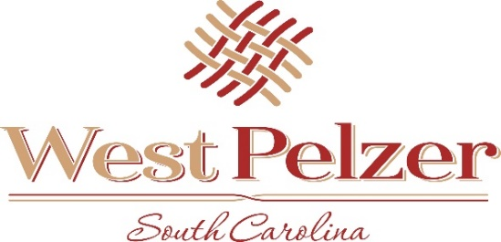
COUNCIL WORK SESSION AGENDA
Friday March 18, 2022
12:00pm
West Pelzer Municipal Center
30 Main Street

- Department Presentations

- Adjourn

