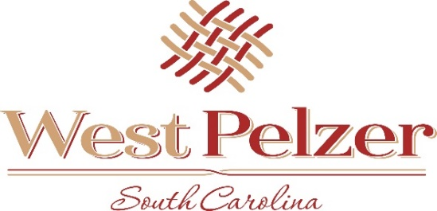
COUNCIL MEETING AGENDA
Monday November 14, 2022
6:00pm
West Pelzer Municipal Center
30 Main Street

- INVOCATION/PLEDGE OF ALLEGIANCE

- CALL TO ORDER

- APPROVAL OF MEETING MINUTES
- September 13, 2022 Council Meeting

- PRESENTATIONS AND REPORTS
- Paula Payton - Clerk’s Report
- Chief Stoller – Police Department Report

- CITIZEN COMMENTS (sign up required / max 3 minutes

- PUBLIC HEARING

- OLD BUSINESS

- NEW BUSINESS
- Resolution 2022-1114 “Appointment of Municipal Court Judge”
- Ordinance 2021-1011.1 “Adoption of International Building Codes Per SC Law”
- 2023 Meeting Schedule

- REQUEST BY COUNCIL

- EXECUTIVE SESSION

- ADJOURNMENT

