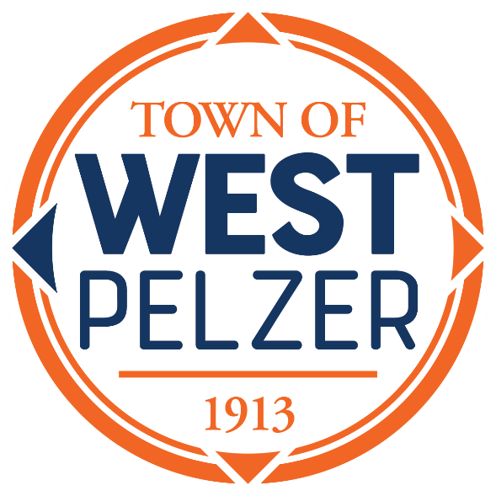

COUNCIL MEETING AGENDA
Tuesday January 9, 2024
6:00pm
West Pelzer Municipal Center
30 Main Street

Swearing in ceremony for Mayor James Riddle,
Councilman Thomas Scarfo & Councilman Tim Williams

- INVOCATION / PLEDGE OF ALLEGIANCE

- CALL TO ORDER

- APPROVAL OF MEETING MINUTES
- December 12, 2023 Council Meeting

- PRESENTATIONS AND REPORTS
- Paula Payton - Clerk’s Report
- Chief Stoller – Police Department Report
- Jeff Pearson – Public Maintenance Report

- CITIZEN COMMENTS (sign up required / max 3 minutes

- OLD BUSINESS

- NEW BUSINESS
- Appointment of Mayor Pro-tem

- REQUEST BY COUNCIL

- EXECUTIVE SESSION

- ADJOURNMENT

A reception will be held immediately following for the newly elected officials

