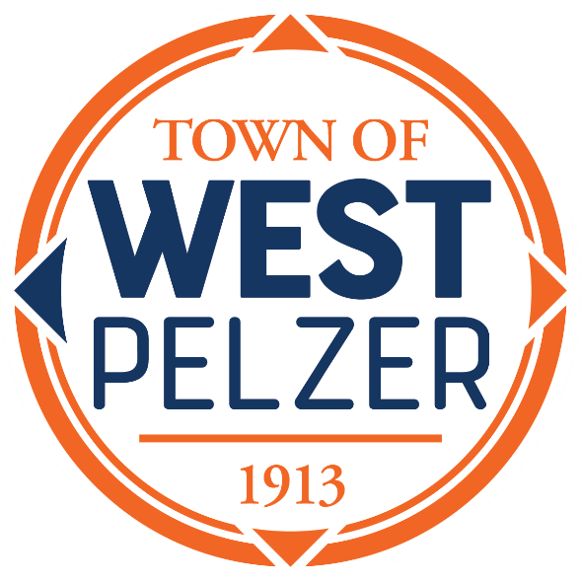

COUNCIL MEETING AGENDA
Tuesday June 11, 2024
6:00pm
West Pelzer Municipal Center
30 Main Street

- MOMENT OF SILENCE/REVERANCE

- PLEDGE OF ALLEGIANCE

- CALL TO ORDER

- APPROVAL OF MEETING MINUTES
- May 14, 2024, Council Meeting
- May 20, 2024, Special Called Meeting
- May 28, 2024, Special Called Meeting

- PRESENTATIONS AND REPORTS
- Paula Payton - Clerk’s Report

- CITIZEN COMMENTS (sign up required / max 3 minutes)

- OLD BUSINESS
- First Reading “Ordinance No. 2024-0611 An Ordinance to Provide for the Adoption of the Operating Budget, its Execution and Effect, for the Fiscal Period of July 1, 2024, through June 30, 2025”

- NEW BUSINESS

- COUNCIL COMMENTS

- EXECUTIVE SESSION

- ADJOURNMENT

