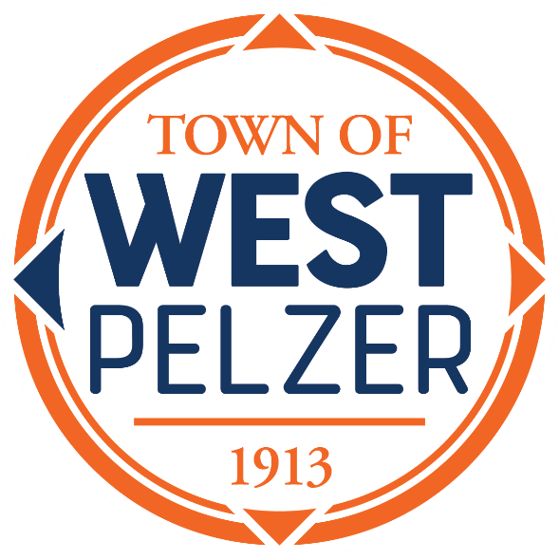

COUNCIL MEETING AGENDA
Tuesday March 14, 2023
6:00pm
West Pelzer Municipal Center
30 Main Street

- INVOCATION/PLEDGE OF ALLEGIANCE

- CALL TO ORDER

- APPROVAL OF MEETING MINUTES
- February 21, 2023 Council Meeting
- March 3, 2023 Budget Workshop

- PRESENTATIONS AND REPORTS
- Paula Payton - Clerk’s Report
- Chief Stoller – Police Department Report
- Mayor Sanders – Proclamation Honoring Emily DeRoberts

- CITIZEN COMMENTS (sign up required / max 3 minutes

- OLD BUSINESS

- NEW BUSINESS
- Resolution 2023-0314 “A RESOLUTION TO MAKE HINDMNAN STREET ONE-WAY FROM MAIN STREET TO THE PUBLIC PARKING ENTRANCE (TMS 2430406017)”
- Ordinance No. 2023-0314 “FIRST READING OF ANNUAL BUDGET FISCAL YEAR 2023-2024”

- REQUEST BY COUNCIL

- EXECUTIVE SESSION

- ADJOURNMENT

