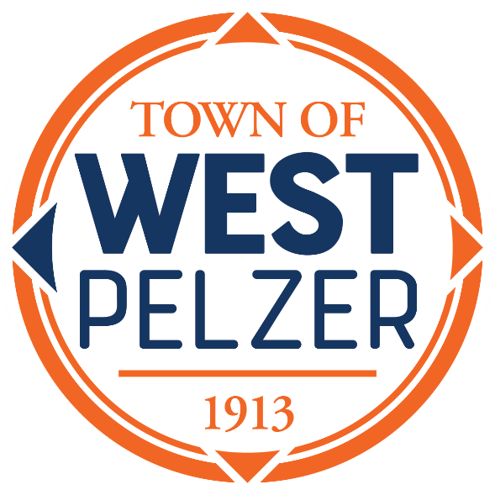

COUNCIL MEETING AGENDA
Tuesday April 11, 2023
6:00pm
West Pelzer Municipal Center
30 Main Street

Swearing in of Councilman Thomas Scarfo
Judge Stephen Turner officiating

A reception will be held immediately following the meeting.

- INVOCATION/PLEDGE OF ALLEGIANCE

- CALL TO ORDER

- APPROVAL OF MEETING MINUTES
- March 14, 2023 Council Meeting

- PRESENTATIONS AND REPORTS
- Paula Payton - Clerk’s Report
- Chief Stoller – Police Department Report

- CITIZEN COMMENTS (sign up required / max 3 minutes

- OLD BUSINESS

- NEW BUSINESS
- Ordinance 2023-0411 “An Ordinance Authorizing and Directing the Town of West Pelzer to Enter Into an Intergovernmental Agreement Relating to South Carolina Local Revenue Service; To Participate in One or More Local Revenue Service Programs; To Execute and Deliver One or More Participant Program Supplements; And Other Matters Relating Thereto”
- Ordinance 2023-0411.1 “An Ordinance Annexing Certain Partial of Land to the Town of West Pelzer, South Carolina; Describing Said Lands and Declaring Same a Part of the Town of West Pelzer, South Carolina; and Amending and Changing the Zoning Map of the Town of West Pelzer, South Carolina, to Show Such Annexation and the Classification for the Same Under the Zoning Ordinance of the Town of West Pelzer, South Carolina; and Providing w=When This Ordinance Shall Become Effective”
- Ordinance 2023-0411.2 “An Ordinance to Authorize Transfer of Property for TMS 2430506008”

- REQUEST BY COUNCIL

- EXECUTIVE SESSION

- ADJOURNMENT

