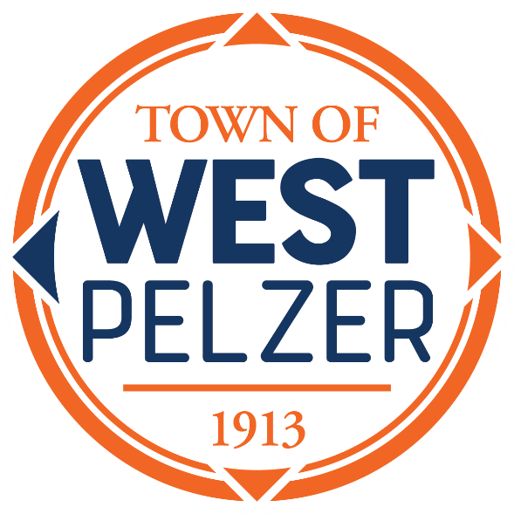

COUNCIL MEETING AGENDA
Tuesday June 13, 2023
6:00pm
West Pelzer Municipal Center
30 Main Street

- CALL TO ORDER

- PROCLAMATION / PLEDGE OF ALLEGIANCE
Mayor Pro-Tem Jim Riddle

- APPROVAL OF MEETING MINUTES
- May 9, 2023 Council Meeting

- PRESENTATIONS AND REPORTS
- Paula Payton - Clerk’s Report
- Chief Stoller – Police Department Report

- CITIZEN COMMENTS (sign up required / max 3 minutes

- OLD BUSINESS

- NEW BUSINESS
- First Reading of Ordinance No. 2023-0613 “An Ordinance for Adoption of the 2021 International Building Code”
- Resolution 2023-0613 “A Resolution to Conduct a Public Hearing Regarding Removal of Three-Way Stops on Secondary Roadways Within the Town of West Pelzer”
- Resolution 2023-0613.1 “A Resolution to Award Streetscape Landscape Contract to Jumpstart Landscaping”

- REQUEST BY COUNCIL

- EXECUTIVE SESSION

- ADJOURNMENT

