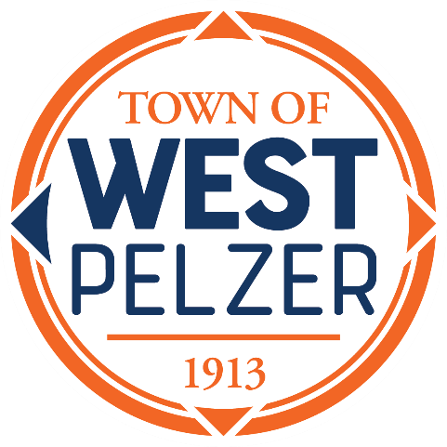

West Pelzer Municipal Election Commission
Agenda
Tuesday March 14, 2023
10:00am
O’Dell Community Center ~ 3 Hindman Street

- Invocation

- Swearing in of MEC Member

- MEC Training Update

- Review of the Official Ballot

- Discussion of Election Day Schedule 3/28/2023

- MEC Hearing 3/30/2023 @ 10am

- Adjourn

