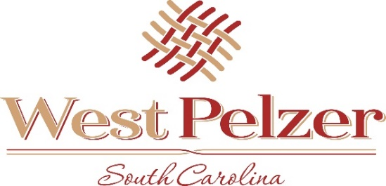
SPECIAL CALLED MEETING AGENDA
Friday November 5, 2021
12:00pm
West Pelzer Municipal Center
30 Main Street

- CALL TO ORDER

- EXECUTIVE SESSION
“RELATED TO THE DISCUSSION OF CONTRACTUAL MATTERS”

- ADJOURNMENT

