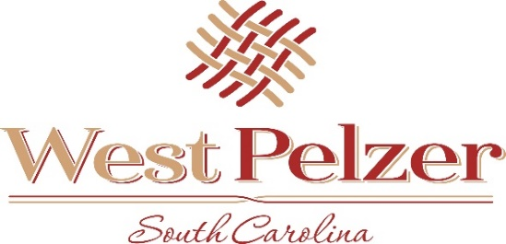
COUNCIL AGENDA
Tuesday August 3, 2021
6:00pm
West Pelzer Municipal Center
30 Main Street

- INVOCATION/PLEDGE OF ALLEGIANCE

- CALL TO ORDER

- APPROVAL OF MEETING MINUTES
  - June 1, 2021 Council Meeting

- PRESENTATIONS AND REPORTS
  - Paula Payton - Clerk’s Report
  - Chief Stoller – Police Department Report
  - Mayor Sanders – Municipal Center Mural / Grace Gilbert

- CITIZEN COMMENTS (sign up required / max 3 minutes

- OLD BUSINESS

- NEW BUSINESS
  - Resolution 2021-0803 “Resolution of Support for Request of Road Funding from the Anderson County
Transportation Committee”
  - Resolution 2021-0803.1 “A Resolution Appropriating the Planning Commission to Update the 2017
Comprehensive Plan for the Town of West Pelzer, South Carolina”
  - Resolution 2021-0803.2 “A Resolution to Conduct a Public Hearing Regarding Additional Four-Way
Stops on Secondary Roadways within the Town of West Pelzer”

- REQUEST BY COUNCIL

- EXECUTIVE SESSION

- ADJOURNMENT

