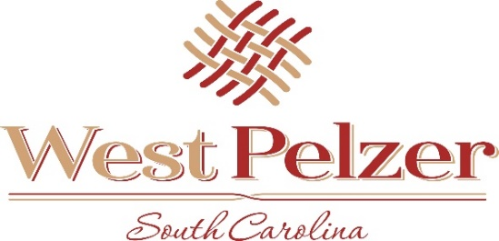
COUNCIL MEETING AGENDA
Tuesday February 8, 2022
6:00pm
West Pelzer Municipal Center
30 Main Street

- INVOCATION/PLEDGE OF ALLEGIANCE

- CALL TO ORDER

- APPROVAL OF MEETING MINUTES
  - January 11, 2022 Council Meeting

- PRESENTATIONS AND REPORTS
  - Paula Payton - Clerk’s Report
  - Chief Stoller – Police Department Report
  - Mayor Blake Sanders – Update on Strategic Planning Session (February 11, 2022)

- CITIZEN COMMENTS (sign up required / max 3 minutes

- OLD BUSINESS

- NEW BUSINESS

- REQUEST BY COUNCIL

- EXECUTIVE SESSION

- ADJOURNMENT

