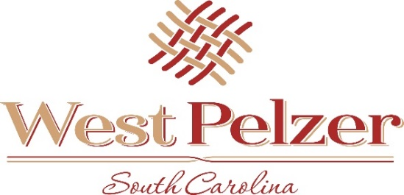
COUNCIL AGENDA
Tuesday October 5, 2021
6:00pm
West Pelzer Municipal Center
30 Main Street

- INVOCATION/PLEDGE OF ALLEGIANCE

- CALL TO ORDER

- APPROVAL OF MEETING MINUTES
  - September 7, 2021 Council Meeting

- PRESENTATIONS AND REPORTS
  - Paula Payton - Clerk’s Report
  - Chief Stoller – Police Department Report

- CITIZEN COMMENTS (sign up required / max 3 minutes

- OLD BUSINESS

- NEW BUSINESS
  - Second Reading of Ordinance 2021-0907 “AN ORDINANCE TO REZONE
APPROXIMATELY 0.80 ACRES OF REAL PROPERTY LOCATED NEAREST 17 PARK STREET,
WEST PELZER, SOUTH CAROLINA. TAX MAP NUMBER 2430413001”
  - Second Reading of Ordinance 2021-0907.1 “AN ORDINANCE TO ADOPT A REVISED
BUSINESS LICENSE ORDINANCE IN ACCORDANCE WITH THE BUSINESS LICENSE
STANDARDIZATOIN ACT (2020 ACT NO. 176)”
  - Resolution 2021-1005 “A RESOLUTION GRANTING A SPECIAL EXCEPTION
PURSUANT TO THE TOWN OF WEST PELZER ZONING ORDINANCE TO PROVIDE FOR IN-
HOME CHILD CARE SERVICE AT 8 PARK STREET, WEST PELZER, SOUTH CAROLINA”
  - Resolution 2021-1005.1 “A RESOLUTION GRANTING A SPECIAL EXCEPTION
PURSUANT TO THE TOWN OF WEST PELZER ZONING ORDINANCE TO PROVIDE FOR IN-
HOME CHILD CARE SERVICE AT 541 WOODCOCK ROAD, WEST PELZER, SOUTH
CAROLINA”

- REQUEST BY COUNCIL

- EXECUTIVE SESSION

- ADJOURNMENT

