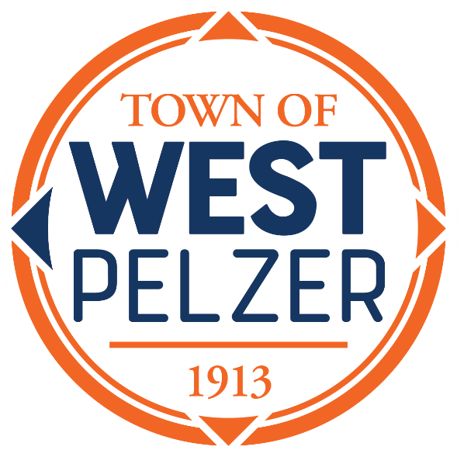

SPECIAL CALLED
COUNCIL MEETING AGENDA
Tuesday April 18, 2023
6:00pm
West Pelzer Municipal Center
30 Main Street

- INVOCATION/PLEDGE OF ALLEGIANCE

- CALL TO ORDER

- OLD BUSINESS
- Ordinance 2023-0411 “An Ordinance Authorizing and Directing the Town of West Pelzer to Enter Into an Intergovernmental Agreement Relating to South Carolina Local Revenue Service; To Participate in One or More Local Revenue Service Programs; To Execute and Deliver One or More Participant Program Supplements; And Other Matters Relating Thereto”
- Ordinance 2023-0411.1 “An Ordinance Annexing Certain Partial of Land to the Town of West Pelzer, South Carolina; Describing Said Lands and Declaring Same a Part of the Town of West Pelzer, South Carolina; and Amending and Changing the Zoning Map of the Town of West Pelzer, South Carolina, to Show Such Annexation and the Classification for the Same Under the Zoning Ordinance of the Town of West Pelzer, South Carolina; and Providing When This Ordinance Shall Become Effective”
- Ordinance 2023-0411.2 “An Ordinance to Authorize Transfer of Property for TMS 2430506008”

- ADJOURNMENT

