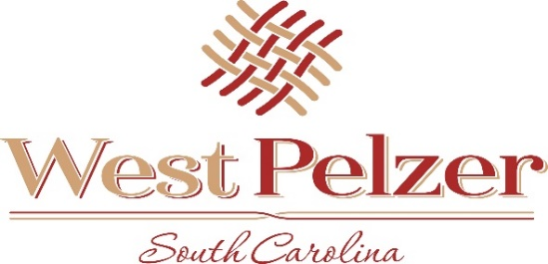
COUNCIL MEETING AGENDA
Tuesday December 7, 2021
6:00pm
West Pelzer Municipal Center
30 Main Street

- INVOCATION/PLEDGE OF ALLEGIANCE

- CALL TO ORDER

- APPROVAL OF MEETING MINUTES
  - November 9, 2021 Council Meeting

- PRESENTATIONS AND REPORTS
  - Paula Payton - Clerk’s Report
  - Chief Stoller – Police Department Report
  - Mayor Blake Sanders
  - Camilla Pittman – City of Greenville Municipal Clerk
  - SCDHEC Upstate Region Health Director Kandi Fredere – Smoke-Free Palmetto State Certificate

- CITIZEN COMMENTS (sign up required / max 3 minutes

- OLD BUSINESS

- NEW BUSINESS
  - Approval of 2022 Regular Scheduled Meeting Dates

- REQUEST BY COUNCIL

- EXECUTIVE SESSION

- ADJOURNMENT

**Reception immediately following the meeting**

