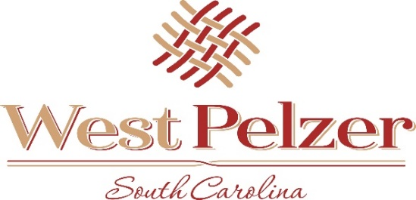
COUNCIL MEETING AGENDA
Tuesday September 13, 2022
6:00pm
West Pelzer Municipal Center
30 Main Street

- INVOCATION/PLEDGE OF ALLEGIANCE

- CALL TO ORDER

- APPROVAL OF MEETING MINUTES
- August 9, 2022 Council Meeting

- PRESENTATIONS AND REPORTS
- Paula Payton - Clerk’s Report
- Chief Stoller – Police Department Report

- CITIZEN COMMENTS (sign up required / max 3 minutes

- PUBLIC HEARING

- OLD BUSINESS
- Final Reading of Ordinance 2022-0510.2 “Annexation and Sewer/Water Service

- NEW BUSINESS

- REQUEST BY COUNCIL

- EXECUTIVE SESSION
- Contractual Matters

- ADJOURNMENT

