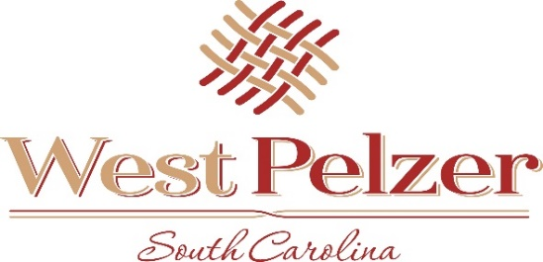
COUNCIL MEETING AGENDA
Tuesday April 19, 2022
6:00pm
West Pelzer Municipal Center
30 Main Street

- INVOCATION/PLEDGE OF ALLEGIANCE

- CALL TO ORDER

- APPROVAL OF MEETING MINUTES
  - March 8, 2022 Council Meeting

- PRESENTATIONS AND REPORTS
  - Paula Payton - Clerk’s Report
  - Chief Stoller – Police Department Report
  - Poet Laureate James Campbell - “What is Love” Poetry Contest
  - SCDOT Commissioner Pam Christopher – School Zone

- CITIZEN COMMENTS (sign up required / max 3 minutes

- OLD BUSINESS
  - Second Reading of Ordinance No. 2022-0208 “AN AORDINANCE TO AMEND THE ZONING
ORDINANCE TO CLARIFY COMMERCIAL ZONING ALONG MAIN STREET”

- NEW BUSINESS
  - First Reading of Ordinance No 2022-0419 “DUKE FRANCHISE AGREEMENT”
  - First Reading of Ordinance No 2022-0419.1 “AMENDMENT TO 2021/2022 BUDGET”
  - Resolution No. 2022-0419.2 “RESOLUTION TO AUTHORIZE THE PAYOFF OF GREENVILLE
WATER BUY-I N AGREEMENT DATEDFISCAL YEAR 2015-2016”1

- REQUEST BY COUNCIL

- EXECUTIVE SESSION

- ADJOURNMENT

