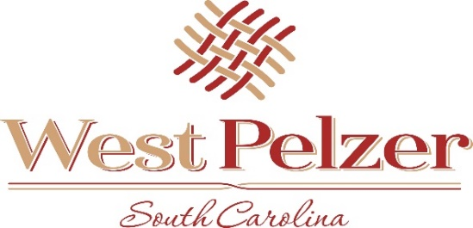

West Pelzer Municipal Center
30 Main Street
West Pelzer, South Carolina 29669

Strategic Planning Work Session Agenda
Friday February 11, 2022
12:00pm

- Strategic Planning
- Adjourn

_____________________________________________________________________________________

Special Called Meeting Agenda
Friday February 11, 2022
Immediately following work session

- Resolution No 2022-0211 “A Resolution to Appropriate American Rescue Plan Act Revenue”

- Adjourn

