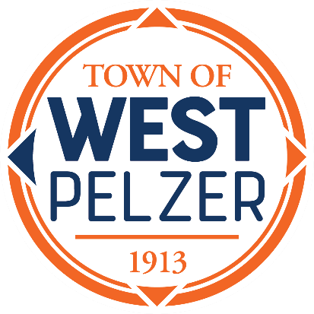

BUDGET WORKSHOP AGENDA
Tuesday May 28, 2024, at 6pm
O’Dell Community Center | 3 Hindman Street | West Pelzer, SC

- CALL TO ORDER

- DISCUSSION OF 2024-2025 FY DRAFT BUDGET

- ADJOURNMENT

SPECIAL CALLED MEETING AGENDA
Tuesday May 28, 2024, at 6:30pm (immediately following workshop)
O’Dell Community Center | 3 Hindman Street | West Pelzer, SC

- CALL TO ORDER

- EXECUTIVE SESSION
- Contractual Matters
- Employee Matters

- ADJOURNMENT

The purpose of this meeting is to hold an executive session.
No action will be taken by Council.

