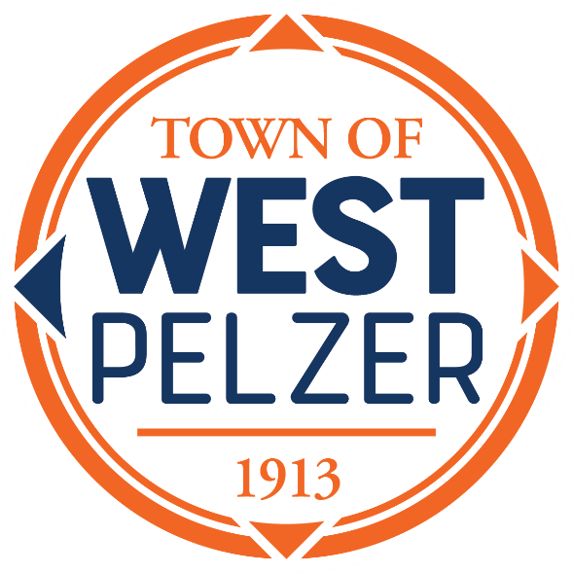

COUNCIL MEETING AGENDA
Tuesday July 11, 2023
6:00pm
West Pelzer Municipal Center
30 Main Street

- INVOCATION / PLEDGE OF ALLEGIANCE

- CALL TO ORDER

- APPROVAL OF MEETING MINUTES
- June 13, 2023 Council Meeting

- PRESENTATIONS AND REPORTS
- Paula Payton - Clerk’s Report
- Chief Stoller – Police Department Report
- Jeff Pearson – Public Maintenance Report
- Councilman Jeff Lee – Motorcycle Awareness Proclamation

- CITIZEN COMMENTS (sign up required / max 3 minutes

- OLD BUSINESS
- Second/Final Reading of Ordinance No. 2023-0613 “An Ordinance for Adoption of the 2021 International Building Code”

- NEW BUSINESS
- Resolution 2023-0711 “A Resolution of the Mayor and Council of the Town of West Pelzer, South Carolina Requesting Membership in the Anderson Area Transportation Study (ANATS)”

- REQUEST BY COUNCIL

- EXECUTIVE SESSION

- ADJOURNMENT

