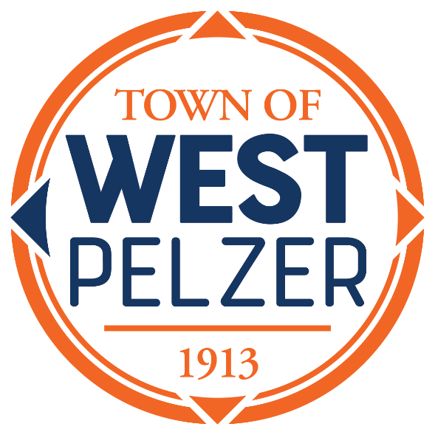

COUNCIL MEETING AGENDA
Tuesday September 10, 2024
6:00pm
West Pelzer Municipal Center
30 Main Street

- MOMENT OF SILENCE/REVERANCE

- PLEDGE OF ALLEGIANCE

- CALL TO ORDER

- APPROVAL OF MEETING MINUTES
- August 13, 2024, Council Meeting

- PRESENTATIONS AND REPORTS
- Paula Payton - Clerk’s Report
- Chief Zachary Owen – Police Department Update

- CITIZEN COMMENTS (sign up required / max 3 minutes)

- OLD BUSINESS

- NEW BUSINESS
- Resolution 2024-0910 “Pledging to Practice and Promote Civility in the Town of West Pelzer”
- Approval of Addendum to Employer Resolution for Participation in the State Insurance Benefits Program regarding Municipality Councilmember Coverage

- COUNCIL COMMENTS

- EXECUTIVE SESSION

- ADJOURNMENT

