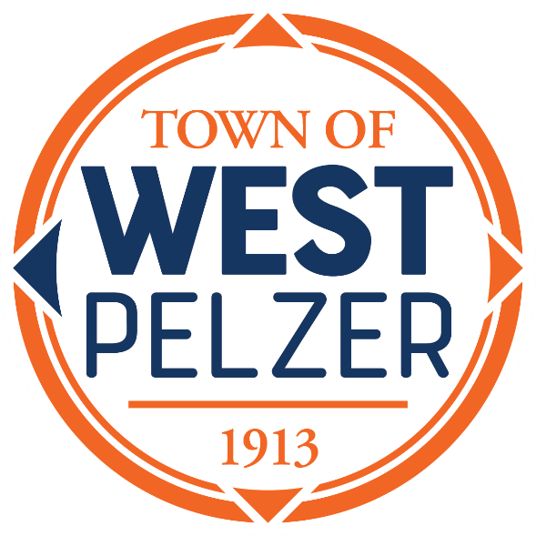

COUNCIL MEETING AGENDA
Tuesday May 14, 2024
6:00pm
West Pelzer Municipal Center
30 Main Street

- MOMENT OF SILENCE/REVERANCE

- PLEDGE OF ALLEGIANCE

- CALL TO ORDER

- APPROVAL OF MEETING MINUTES
- April 23, 2024, Council Meeting

- PRESENTATIONS AND REPORTS
- Paula Payton - Clerk’s Report
- Chief Stoller – Police Department Report

- CITIZEN COMMENTS (sign up required / max 3 minutes)

- PUBLIC HEARING
“Ordinance No. 2024-0423 An Ordinance Approving & Authorizing the Transfer & Sale of the Town of West Pelzer Water System to the Board of Commissioners of Public Works of the City of Greenville (Greenville Water)”

- OLD BUSINESS
a) Second Reading “Ordinance No. 2024-0423 An Ordinance Approving & Authorizing the Transfer & Sale of the Town of West Pelzer Water System to the Board of Commissioners of Public Works of the City of Greenville (Greenville Water)”

- NEW BUSINESS
- First Reading “Ordinance No. 2024-0514 An Ordinance to Provide for the Adoption of the Operating Budget, its Execution and Effect, for the Fiscal Period of July 1, 2024, through June 30, 2025”

- COUNCIL COMMENTS

- EXECUTIVE SESSION

- ADJOURNMENT

