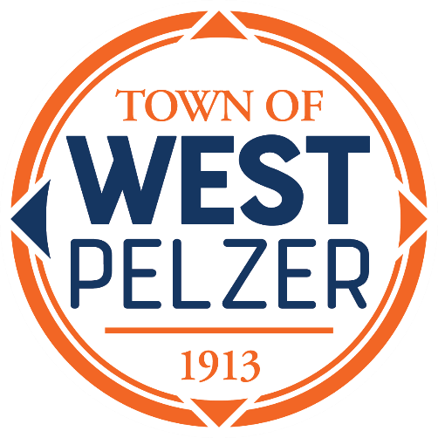

Budget Workshop Agenda
Friday May 23, 2025
6:00pm
West Pelzer Municipal Center
30 Main Street

- Call to Order

- Review of 2024/2025 Budget

- Department Requests & Discussion

- Capital Projects & Grant Funding

- Executive Session
Re: Employee Salaries

- Adjourn

**No votes will be taken. The workshop is for discussion only. All votes on budget items will be made at the June 10, 2025, Council Meeting, following the Public Hearing**

