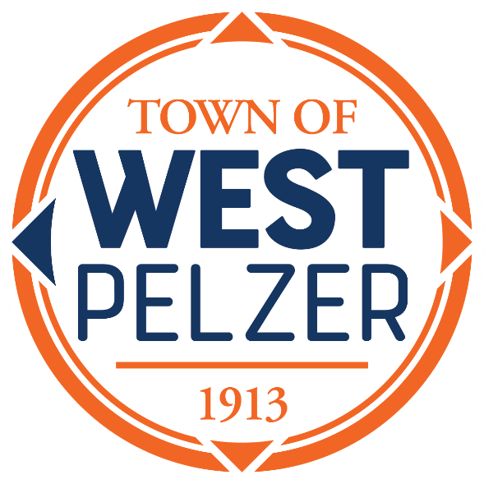

SPECIAL CALLED MEETING AGENDA
Tuesday March 19, 2024
6:00pm
West Pelzer Municipal Center
30 Main Street

- MOMENT OF SILENCE/REVERANCE

- PLEDGE OF ALLEGIANCE

- CALL TO ORDER

- NEW BUSINESS
- Discussion and Approval of an Agreement to Operate a Water System Between Greenville Water and Town of West Pelzer

- EXECUTIVE SESSION

- ADJOURNMENT

