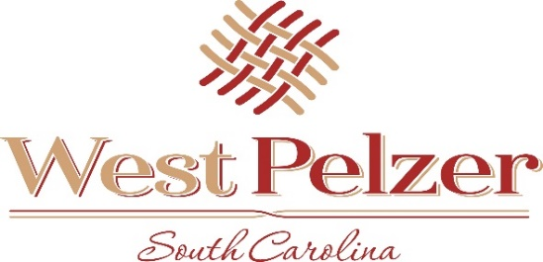
COUNCIL MEETING AGENDA
Tuesday January 11, 2022
6:00pm
West Pelzer Municipal Center
30 Main Street

Swearing In of Councilman Johnny Rogers and Jeff Lee

- INVOCATION/PLEDGE OF ALLEGIANCE

- CALL TO ORDER

- APPROVAL OF MEETING MINUTES
  - December 7, 2021 Council Meeting

- PRESENTATIONS AND REPORTS
  - Paula Payton - Clerk’s Report
  - Chief Stoller – Police Department Report

- CITIZEN COMMENTS (sign up required / max 3 minutes

- OLD BUSINESS
  - Second Reading of Ordinance 2021-1109 “AN ORDINANCE TO PROVIDE FOR
THE AMENDMENT OF AN OPERATING BUDGET, ITS EXECUTION AND
EFFECT, FOR THE FISCAL PERIOD JULY 1, 2021 THROUGH JUNE 30, 2022”

- NEW BUSINESS

- REQUEST BY COUNCIL

- EXECUTIVE SESSION

- ADJOURNMENT

**Reception immediately following the meeting**

