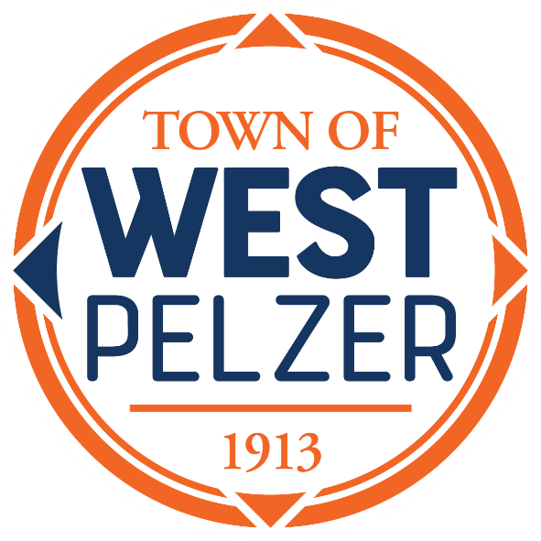

BUDGET WORKSHOP
Friday April 28, 2023
12:00pm
O’Dell Community Center
3 Hindman Street

- CALL TO ORDER

- BUDGET REVIEW
FY 2023-2024

- ADJOURNMENT

