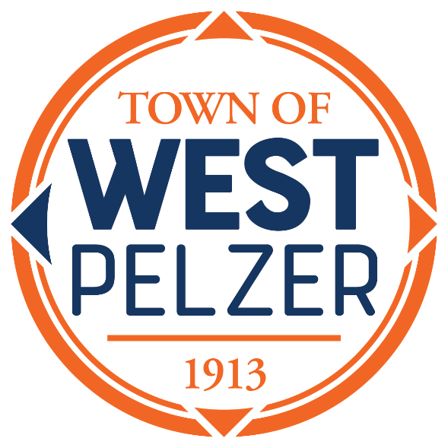

COUNCIL MEETING AGENDA
Tuesday July 9, 2024
6:00pm
West Pelzer Municipal Center
30 Main Street

- MOMENT OF SILENCE/REVERANCE

- PLEDGE OF ALLEGIANCE

- CALL TO ORDER

- APPROVAL OF MEETING MINUTES
- June 11, 2024, Council Meeting

- PRESENTATIONS AND REPORTS
- Paula Payton - Clerk’s Report
- Charlie Nix – Maintenance Report
- Swearing-In of Police Chief Zachary Owen

- CITIZEN COMMENTS (sign up required / max 3 minutes)

- PUBLIC HEARING
“Ordinance No. 2024-0611 An Ordinance to Provide for the Adoption of
the Operating Budget, its Execution and Effect, for the Fiscal Period of July 1, 2024, through June 30,
2025”

- OLD BUSINESS
- Second Reading “Ordinance No. 2024-0611 An Ordinance to Provide for the Adoption of the Operating Budget, its Execution and Effect, for the Fiscal Period of July 1, 2024, through June 30, 2025”

- NEW BUSINESS

- COUNCIL COMMENTS

- EXECUTIVE SESSION

- ADJOURNMENT

**Reception will be held immediately following the meeting**

