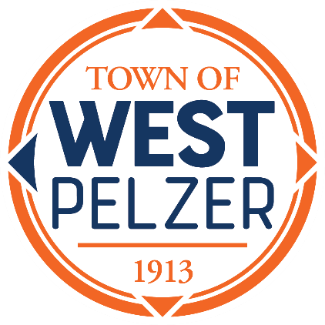

Council Roundtable Discussion
Wednesday October 30, 2024
10am-12pm
O’Dell Community Center
3 Hindman Street
West Pelzer, South Carolina 29669

- Roundtable Discussion with Mayor & Council hosted by Naomi Reed
with the Municipal Association of South Carolina

**The purpose of this meeting is discussion only;
no votes will be taken by Council**


Planning Commission Training
Wednesday October 30, 2024
1pm-4pm
O’Dell Community Center
3 Hindman Street
West Pelzer, South Carolina 29669

- Required Annual Continuing Education Training hosted by Naomi Reed
with the Municipal Association of South Carolina

**The purpose of this meeting is for training only;
no votes will be taken by the Planning Commission**

