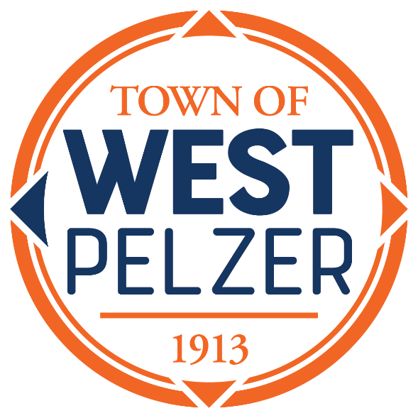

COUNCIL MEETING AGENDA
Tuesday August 8, 2023
6:00pm
West Pelzer Municipal Center
30 Main Street

- INVOCATION / PLEDGE OF ALLEGIANCE

- CALL TO ORDER

- APPROVAL OF MEETING MINUTES
- July 11, 2023 Council Meeting

- PRESENTATIONS AND REPORTS
- Paula Payton - Clerk’s Report
- Chief Stoller – Police Department Report
- Jeff Pearson – Public Maintenance Report
- Municipal Association of SC – Naomi Reed – Achievement Award

- CITIZEN COMMENTS (sign up required / max 3 minutes

- OLD BUSINESS

- NEW BUSINESS
- Resolution 2023-0808 “A Resolution by the Mayor and Council of the Town of West Pelzer to Grant an Easement for Access to Renewable Water Resources (REWA) for the Access Across Property of the Town Located on Mill Street and Woodcock road, Tax Parcel No. 2430004033; To Authorize the Mayor and Town Clerk to Execute and Deliver Documents Necessary for the Conveyance of Said Easement; To Set An Effective Date; and for Other Lawful Purposes”
- Resolution 2023-0808.1 “A Resolution of the Town of West Pelzer Adopting the 2023 Multi-Jurisdictional Hazard Mitigation Plan Anderson & Oconee County”

- REQUEST BY COUNCIL

- EXECUTIVE SESSION

- ADJOURNMENT

