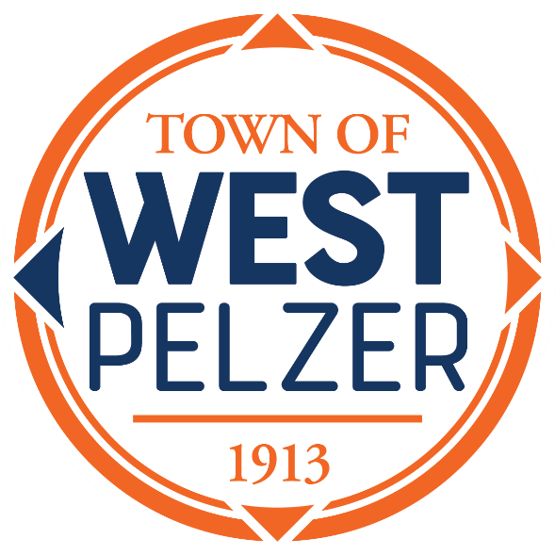

COUNCIL MEETING AGENDA
Tuesday December 12, 2023
6:00pm
West Pelzer Municipal Center
30 Main Street

- INVOCATION / PLEDGE OF ALLEGIANCE

- CALL TO ORDER

- APPROVAL OF MEETING MINUTES
- November 14, 2023 Council Meeting

- PRESENTATIONS AND REPORTS
- Paula Payton - Clerk’s Report
- Chief Stoller – Police Department Report
- Jeff Pearson – Public Maintenance Report
- Mayor-elect Jim Riddle – Mayor’s Recognition

- CITIZEN COMMENTS (sign up required / max 3 minutes

- OLD BUSINESS
- Second/Final Reading of Ordinance 2023-0509 “Adoption of Zoning Ordinance”

- NEW BUSINESS
- Approval of the 2024 Meeting Schedule

- REQUEST BY COUNCIL

- EXECUTIVE SESSION

- ADJOURNMENT

A reception will be held immediately following the meeting in honor of Mayor Blake Sanders

