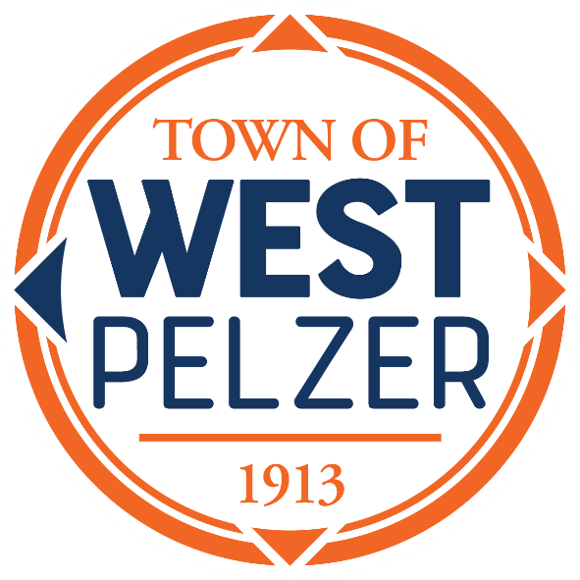

BUDGET WORKSHOP
Friday March 29, 2024
12:00pm
Municipal Center Conference Room
30 Main Street

- CALL TO ORDER

- BUDGET OVERVIEW
FY 2023-2024

- DISCUSSION OF 2024-2025 FISCAL YEAR BUDGET
      - Department Requests
      - Capital Projects

- EXECUTIVE SESSION
For the purpose of discussion of contractual matters related to the 2024-2025 fiscal year budget

- ADJOURNMENT

NO ACTION WILL BE TAKEN

