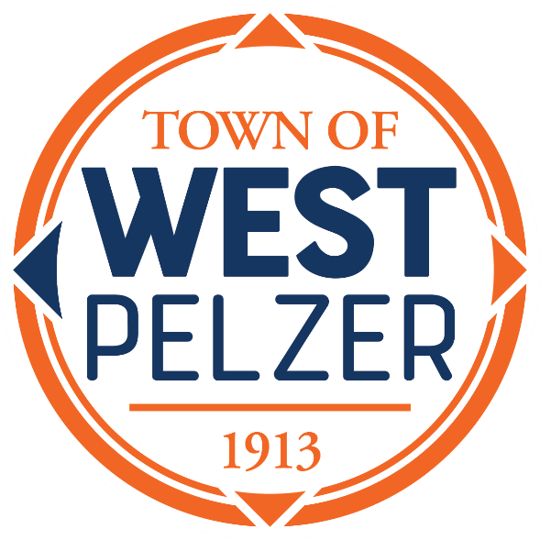

SPECIAL CALLED MEETING AGENDA
Monday May 20, 2024
6:00pm
West Pelzer Municipal Center
30 Main Street

- CALL TO ORDER

- EXECUTIVE SESSION
- Contractual Matters
- Employee Matters

- ADJOURNMENT

The purpose of this meeting is to hold an executive session.
No action will be taken by Council.

