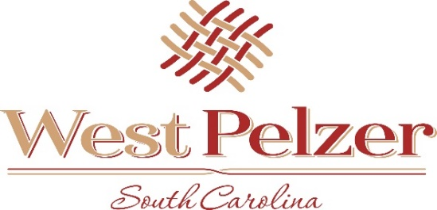
COUNCIL MEETING AGENDA
Tuesday August 9, 2022
6:00pm
West Pelzer Municipal Center
30 Main Street

- INVOCATION/PLEDGE OF ALLEGIANCE

- CALL TO ORDER

- APPROVAL OF MEETING MINUTES
- June 21, 2022 Council Meeting

- PRESENTATIONS AND REPORTS
- Paula Payton - Clerk’s Report
- Chief Stoller – Police Department Report

- CITIZEN COMMENTS (sign up required / max 3 minutes

- PUBLIC HEARING
- Re: Ordinance No 2022-0510.2 “ANNEXATION AND SEWER/WATER SERVICE”

- OLD BUSINESS

- NEW BUSINESS

- REQUEST BY COUNCIL

- EXECUTIVE SESSION
- Contractual Matters

- ADJOURNMENT

