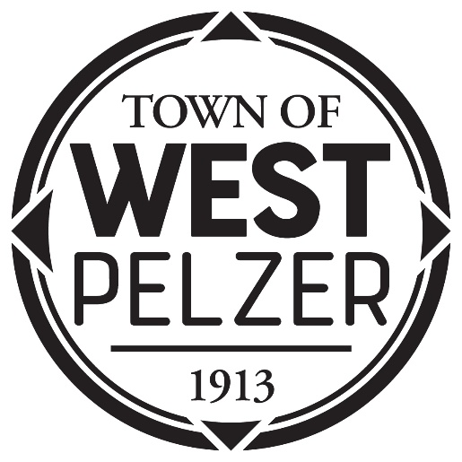

COUNCIL MEETING AGENDA
Tuesday February 21, 2023
6:00pm
West Pelzer Municipal Center
30 Main Street

- INVOCATION/PLEDGE OF ALLEGIANCE

- CALL TO ORDER

- APPROVAL OF MEETING MINUTES
- January 10, 2023 Council Meeting

- PRESENTATIONS AND REPORTS
- Paula Payton - Clerk’s Report
- Chief Stoller – Police Department Report

- CITIZEN COMMENTS (sign up required / max 3 minutes

- OLD BUSINESS

- NEW BUSINESS
- Resolution 2023-0221 “APPOINTMENT OF PLANNING COMMISSION MEMBER”

- REQUEST BY COUNCIL

- EXECUTIVE SESSION

- ADJOURNMENT

