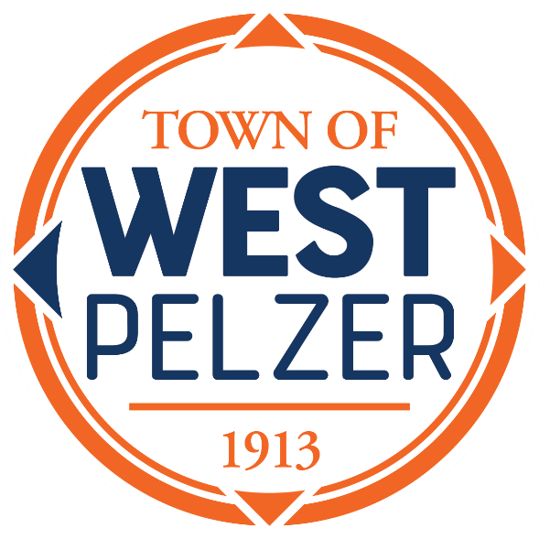

COUNCIL MEETING AGENDA
Tuesday May 9, 2023
6:00pm
West Pelzer Municipal Center
30 Main Street

- INVOCATION/PLEDGE OF ALLEGIANCE

- CALL TO ORDER

- APPROVAL OF MEETING MINUTES
- April 11, 2023 Council Meeting
- April 18, 2023 Special Called Meeting

- PRESENTATIONS AND REPORTS
- Paula Payton - Clerk’s Report
- Chief Stoller – Police Department Report
- Mayor Sanders – Employee Appreciation Proclamation

- CITIZEN COMMENTS (sign up required / max 3 minutes

- PUBLIC HEARING
- 2023-2024 Budget

- OLD BUSINESS
- Second/Final Reading of Ordinance 2023-0314 “An Ordinance to Provide for the Adoption of an Operating Budget, Its Execution and Effect, For the Fiscal Period July 1, 2023 Through June 30, 2024”

- NEW BUSINESS
- Resolution 2023-0509 “A Resolution to Adopt the Comprehensive Master Plan of the Town of West Pelzer, Anderson County, South Carolina”
- First Reading of Ordinance 2023-0509 “An Ordinance Adopting a Zoning Ordinance for the Town of West Pelzer, South Carolina, to Implement the Comprehensive Plan Adopted Pursuant to the South Carolina Local Government Comprehensive Planning Enabling Act of 1994”

- REQUEST BY COUNCIL

- EXECUTIVE SESSION
- Contractual Matters

- ADJOURNMENT

