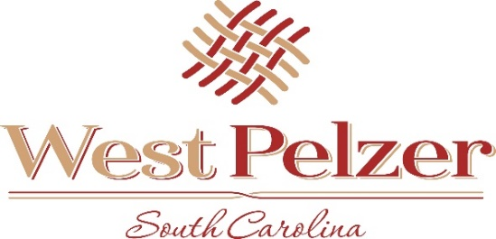
COUNCIL MEETING AGENDA
Tuesday March 8, 2022
6:00pm
West Pelzer Municipal Center
30 Main Street

- INVOCATION/PLEDGE OF ALLEGIANCE

- CALL TO ORDER

- APPROVAL OF MEETING MINUTES
  - February 8, 2022 Council Meeting
  - February 11, 2022 Special Called Meeting

- PRESENTATIONS AND REPORTS
  - Paula Payton - Clerk’s Report
  - Chief Stoller – Police Department Report

- CITIZEN COMMENTS (sign up required / max 3 minutes

- OLD BUSINESS

- NEW BUSINESS
  - First Reading of Ordinance No 2022-0208 “AN ORDINANCE TO AMEND THE ZONING ORDIANCE TO CLARIFY COMMERCIAL ZOING ALONG MAIN STREET”
  - Resolution No 2022-0308 “A RESOLUTION TO APPOINT MEMBERS TO THE PLANNING COMMISSION FOR THE TOWN OF WEST PELZER, SOUTH CAROLINA”

- REQUEST BY COUNCIL

- EXECUTIVE SESSION

- ADJOURNMENT

