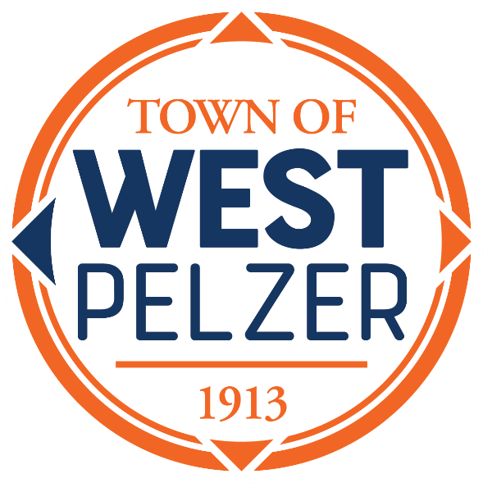

COUNCIL MEETING AGENDA
Tuesday November 14, 2023
6:00pm
West Pelzer Municipal Center
30 Main Street

- INVOCATION / PLEDGE OF ALLEGIANCE

- CALL TO ORDER

- APPROVAL OF MEETING MINUTES
- October 10, 2023 Council Meeting

- PRESENTATIONS AND REPORTS
- Paula Payton - Clerk’s Report
- Chief Stoller – Police Department Report
- Jeff Pearson – Public Maintenance Report

- CITIZEN COMMENTS (sign up required / max 3 minutes

- OLD BUSINESS
- Second/Final Reading of Ordinance 2023-0912 “An Ordinance Amending the Business License Ordinance of the Town of West Pelzer to Update the Class Schedule as Required by Act 176 of 2020”

- NEW BUSINESS

- REQUEST BY COUNCIL

- EXECUTIVE SESSION

- ADJOURNMENT

