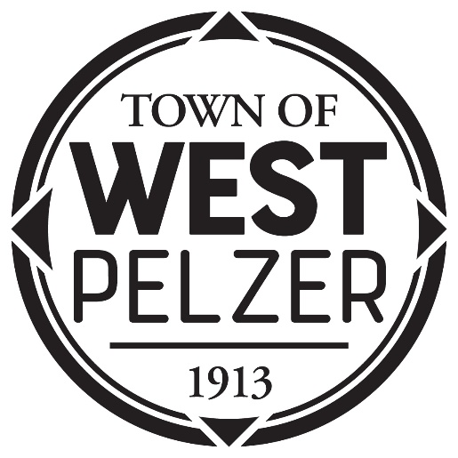

COUNCIL MEETING AGENDA
Tuesday January 10, 2023
6:00pm
West Pelzer Municipal Center
30 Main Street

- INVOCATION/PLEDGE OF ALLEGIANCE

- CALL TO ORDER

- APPROVAL OF MEETING MINUTES
- December 13, 2022 Council Meeting

- PRESENTATIONS AND REPORTS
- Paula Payton - Clerk’s Report
- Chief Stoller – Police Department Report
- Swearing In of Judge Stephen Turner

- CITIZEN COMMENTS (sign up required / max 3 minutes

- OLD BUSINESS
- Second Reading of Ordinance 2022-1213 “AN ORDINANCE TO REZONE APPROXIMATELY 5 ACRES OF REAL PROPERTY LOCATED NEAREST 501 WOODCOCK ROAD AND 190 MILL STREET, WEST PELZER, SOUTH CAROLINA 29669 (TAX MAP NUMBERS 2431301023, 2431301024, 2431301005, 2431301004, 2431301003, 2431301002, 2431301001, 2431302002, 2431302001) TO R-6 HIGH DENSITY RESIDENTIAL / MULTI-FAMILY”

- NEW BUSINESS
- Discussion to Repeal Town Code 18.202 “Manner of Driving a Motor Vehicle, Points
- Resolution 2023-0110 “A RESOLUTION TO ACCEPT 2023 P.A.R.D. GRANT FUNDING”
- Resolution 2023-0110.1 “APPOINTMENT OF MUNICIPAL ELECTION COMMITTEE MEMBER”

- REQUEST BY COUNCIL

- EXECUTIVE SESSION

- ADJOURNMENT

** A reception will follow for Judge Turner**

