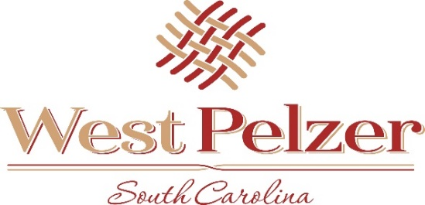
COUNCIL MEETING AGENDA
Tuesday November 9, 2021
6:00pm
West Pelzer Municipal Center
30 Main Street

- INVOCATION/PLEDGE OF ALLEGIANCE

- CALL TO ORDER

- APPROVAL OF MEETING MINUTES
  - October 5, 2021 Council Meeting
  - November 5, 2021 Special Called Meeting

- PRESENTATIONS AND REPORTS
  - Paula Payton - Clerk’s Report
  - Chief Stoller – Police Department Report

- CITIZEN COMMENTS (sign up required / max 3 minutes

- OLD BUSINESS

- NEW BUSINESS
  - Resolution 2021-1109 “RESOLUTION OF SUPPORT FOR REQUEST OF ROAD
FUNDING FROM THE ANDERSON COUNTY TRANSPORTATION
COMMITTEE”
  - First Reading of Ordinance 2021-1109 “AN ORDINANCE TO PROVIDE FOR THE
AMENDMENT OF AN OPERATING BUDGET, ITS EXECUTION AND EFFECT,
FOR THE FISCAL PERIOD JULY 1, 2021 THROUGH JUNE 30, 2021”

- REQUEST BY COUNCIL

- EXECUTIVE SESSION

- ADJOURNMENT

